Order of Worship
May 19, 2024

Welcome and Announcements
Prayer
Children’s Offering
Songs of Worship
Your Grace Is Enough………………..…………….….…………….…………….…...On Screen
What a Mighty God We Serve.……………….……..…….……………...……….On Screen
No, Not One……………..……..……………………………………………..…….………Hymn 181
Spirit of the Living God………..….………..…………………….….…………………Hymn 244
Special Music
Sermon
Why We Need the Gospel: No One Is Righteous..…………………..Rev. Tim Fisher Romans 3:1-20
Song of Invitation
Turn Your Eyes Upon Jesus...………………………………………………………….Hymn 320

We love having children in the worship service. However, a nursery is provided for infants and toddlers if you want to use it.

Why We Need the Gospel: No One Is Righteous – Romans 3:1-20
Main Idea: God’s Law proves that no one is righteous, thus showing us our desperate need for salvation in Jesus Christ.
- In the classroom with Paul (Romans 3:1-8)
  - What advantage does the Jew have? (Rom. 3:1-2)
  - Does Jewish unfaithfulness nullify God’s faithfulness? (Rom. 3:3-4)
  - Are we doing God a favor by sinning? (Rom. 3:5-8)
- In the Courtroom with Paul (Romans 3:9-20)
  - The accusation (Rom. 3:9)
  - The evidence (Rom. 3:10-18)
  - The verdict (Rom. 3:19-20)

The Way of Salvation
- Everyone needs salvation because we are all sinners.
Romans 3:23: for all have sinned and fall short of the glory of God,
- The price of sin is death.
Romans 6:23: For the wages of sin is death, but the free gift of God is eternal life in Christ Jesus our Lord.
- Jesus paid the price for our sin.
Romans 5:8: But God demonstrates His own love toward us, in that while we were yet sinners, Christ died for us.
- We receive salvation and eternal life through faith in Jesus.
Romans 10:9: that if you confess with your mouth Jesus as Lord, and believe in your heart that God raised Him from the dead, you will be saved;
- Salvation through Jesus bring us into a peaceful relationship with God.
Romans 5:1: Therefore, having been justified by faith, we have peace with God through our Lord Jesus Christ,
Romans 8:1: Therefore there is now no condemnation for those who are in Christ Jesus.
How to personally receive salvation
- Admit you are a sinner.
- Understand that as a sinner, you deserve death.
- Believe that Jesus died on the cross to save you from sin and death.
- Repent by turning from your old life of sin to a new life of following Jesus.
- Receive the free gift of salvation through faith in Jesus Christ.

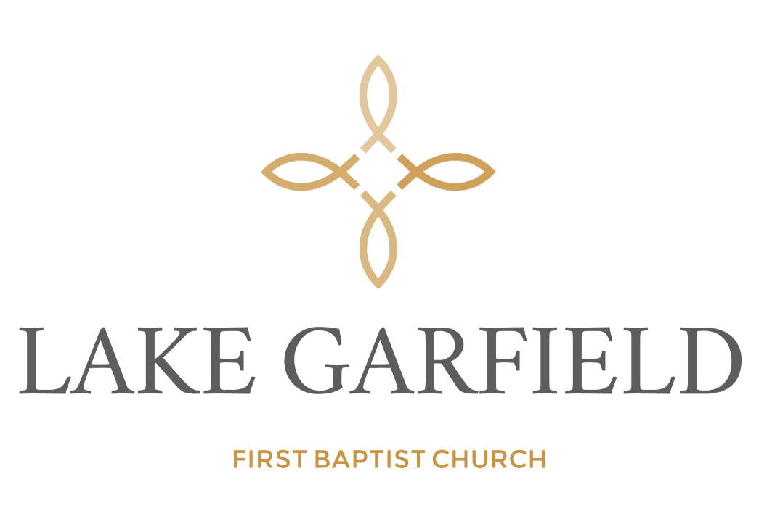

Order of Service

May 19, 2024

