Order of Worship
April 28, 2024

Welcome and Announcements
Prayer
Children’s Offering
Songs of Worship
Come………………………………………….….…………….…………….………………...On Screen
Are You Washed in the Blood………………….……..…….……………...……….Hymn 136
Alleluia………………....…………………..……..…………………………….…….………Hymn 223
Just a Closer Walk with Thee.….………..…………………….….…………………Hymn 448
Special Music
Sermon
The Wrath of a Loving God, Part 2………..……….……………………..Rev. Tim Fisher Romans 1:22-32
Song of Invitation
Have Thine Own Way, Lord.………………………………………………………….Hymn 294

We love having children in the worship service. However, a nursery is provided for infants and toddlers if you want to use it.

The Wrath of a Loving God, Part 2 – Romans 1:22-32
Main Idea: God’s wrath is often displayed by consigning people to the consequences of their sins in order to get them to see the error of their ways and turn to him.
- God hands people over to impurity. (Romans 1:22-24)
  - The reason: They exchanged God’s glory for idols. (Rom. 1:22-23)
  - The handing over: to impurity (Rom. 1:24b)
  - The result: their bodies are dishonored (Rom. 1:24c)
- God hands people over to dishonoring passions. (Romans 1:25-27)
  - The reason: exchanged the truth of God for the lie (Rom. 1:25)
  - The handing over: to dishonoring passions (Rom. 1:26a)
  - The result: They exchange the natural for the unnatural. (Rom. 1:26b-27)
- God hands people over to a depraved mind. (Romans 1:28-32)
  - The reason: They no longer acknowledge God. (Rom. 1:28a)
  - The handing over: to a depraved mind (Rom. 1:28b)
  - The results (Rom. 1:28c-32)
    - Doing what is not proper (Rom. 1:28c) Behavior always follows thinking.
    - Filled with every imaginable vice (Rom. 1:29-31)
    - Practice and approve things contrary to God’s law (Rom. 1:32)

The Way of Salvation
- Everyone needs salvation because we are all sinners.
Romans 3:23: for all have sinned and fall short of the glory of God,
- The price of sin is death.
Romans 6:23: For the wages of sin is death, but the free gift of God is eternal life in Christ Jesus our Lord.
- Jesus paid the price for our sin.
Romans 5:8: But God demonstrates His own love toward us, in that while we were yet sinners, Christ died for us.
- We receive salvation and eternal life through faith in Jesus.
Romans 10:9: that if you confess with your mouth Jesus as Lord, and believe in your heart that God raised Him from the dead, you will be saved;
- Salvation through Jesus bring us into a peaceful relationship with God.
Romans 5:1: Therefore, having been justified by faith, we have peace with God through our Lord Jesus Christ,
Romans 8:1: Therefore there is now no condemnation for those who are in Christ Jesus.
How to personally receive salvation
- Admit you are a sinner.
- Understand that as a sinner, you deserve death.
- Believe that Jesus died on the cross to save you from sin and death.
- Repent by turning from your old life of sin to a new life of following Jesus.
- Receive the free gift of salvation through faith in Jesus Christ.

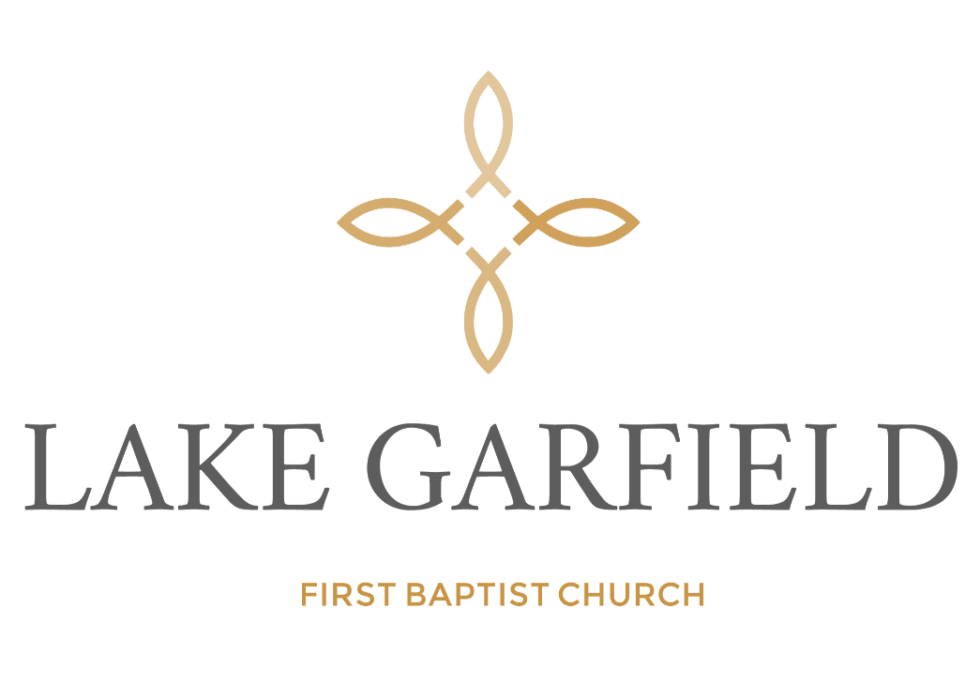

Order of Service

April 28, 2024

