Order of Worship
April 14, 2024

Welcome and Announcements
Prayer
Children’s Offering
Songs of Worship
Blessed Be Your Name.…..…………………………….…………….………………...On Screen
He Keeps Me Singing…..………………………….……..…….……………...……….Hymn 425
Surely Goodness and Mercy....…..……..…………………………….…….………Hymn 422
Blessed Assurance...………………….…………………………….….…………………Hymn 334
Special Music
Sermon
Gospel Motivation………………………………..……….……………………..Rev. Tim Fisher Romans 1:8-17
Song of Invitation
I Have Decided to Follow Jesus….………………………………………………….Hymn 305

We love having children in the worship service. However, a nursery is provided for infants and toddlers if you want to use it.

Gospel Motivation – Romans 1:8-17
Main Idea: We should be motivated to share the Gospel because it alone can change sinners and bring them into a saving relationship with God.
- First Motivation: Thanksgiving (Romans 1:8-10)
  - Thanksgiving through Jesus Christ. (Rom. 1:8a)
  - Thanksgiving for the church. (Rom. 1:8b)
  - Thanksgiving for others leads to prayer for others. (Rom. 1:9-10)
- Second Motivation: Mutual Encouragement (Romans 1:11-13)
  - We should focus on strengthening other believers by sharing our spiritual gifts. (Rom. 1:11)
  - We should allow others to strengthen us by using their spiritual gifts. (Rom. 1:12)
  - Mutual encouragement bears fruit for God’s Kingdom. (Rom. 1:13)
- Third Motivation: Obligation (Romans 1:14-15)
  - Those who have believed the Gospel have an obligation to share it with everyone. (Rom. 1:14)
  - The obligation to share the gospel is NOT a joyless commitment to an unpleasant task. (Rom. 1:15)
- Fourth Motivation: Confidence in the power of the Gospel (Romans 1:16-17)
  - It is the expression of God’s power. (Rom. 1:16)
    - We should not be ashamed of it.
    - It results in salvation.
    - For everyone who believes.
  - It is the revelation of God’s righteousness. (Rom. 1:17, see Isa. 46:13)
    - Entirely by faith.
    - Affirmed by God’s Word.

The Way of Salvation
- Everyone needs salvation because we are all sinners.
Romans 3:23: for all have sinned and fall short of the glory of God,
- The price of sin is death.
Romans 6:23: For the wages of sin is death, but the free gift of God is eternal life in Christ Jesus our Lord.
- Jesus paid the price for our sin.
Romans 5:8: But God demonstrates His own love toward us, in that while we were yet sinners, Christ died for us.
- We receive salvation and eternal life through faith in Jesus.
Romans 10:9: that if you confess with your mouth Jesus as Lord, and believe in your heart that God raised Him from the dead, you will be saved;
- Salvation through Jesus bring us into a peaceful relationship with God.
Romans 5:1: Therefore, having been justified by faith, we have peace with God through our Lord Jesus Christ,
Romans 8:1: Therefore there is now no condemnation for those who are in Christ Jesus.
How to personally receive salvation
- Admit you are a sinner.
- Understand that as a sinner, you deserve death.
- Believe that Jesus died on the cross to save you from sin and death.
- Repent by turning from your old life of sin to a new life of following Jesus.
- Receive the free gift of salvation through faith in Jesus Christ.

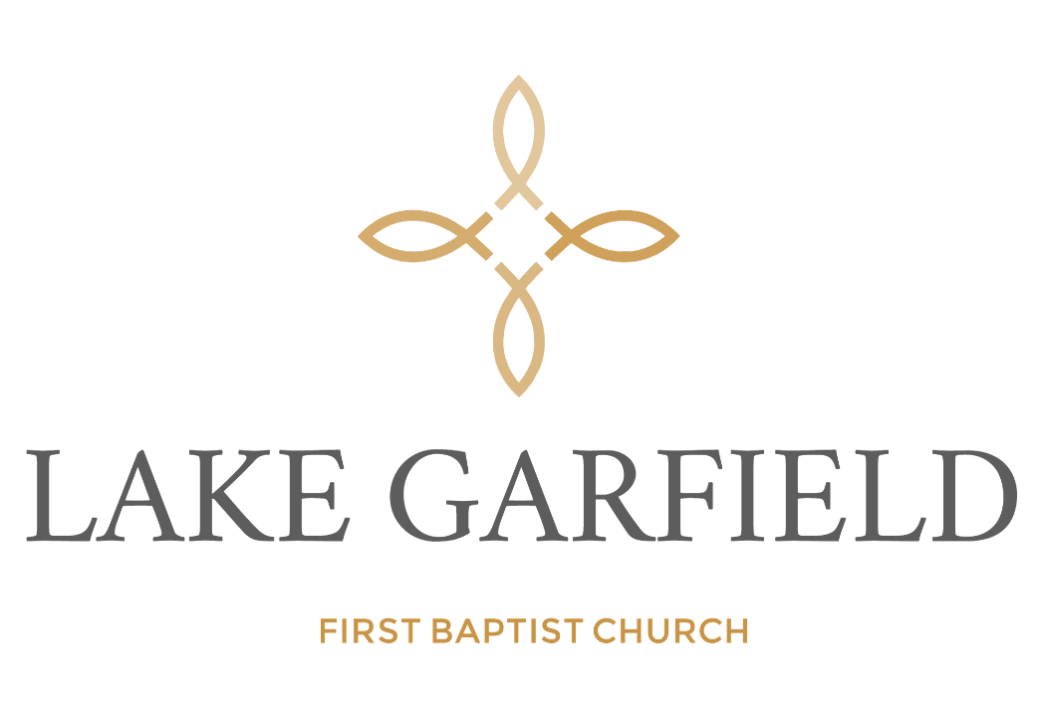

Order of Service

April 14, 2024

