The King Who Brings Salvation – Mark 11:1-11
Main Idea: You should surrender your allegiance to King Jesus.
- Jesus is always in control. (Mark 11:1-3)
  - His purpose was prophesied. (see Zec. 9:9)
  - His coming was calculated.
- Jesus deserves your obedience. (Mark 11:4-6)
  - Do you trust His plan?
  - Is your property at His disposal?
- Jesus is worthy of your worship. (Mark 11:7-8)
  - Will you go out of your way to worship Jesus?
  - Is Jesus the one being honored in your worship?
  - Do you worship Jesus outside of the church building?
- Jesus is the only one who can bring you eternal salvation. (Mark 11:9-11)
  - Don’t seek the wrong kind of salvation. (see 1 Cor. 15:19)
  - Seek the salvation that Jesus brings.

The King Who Brings Salvation – Mark 11:1-11
Main Idea: You should surrender your allegiance to King Jesus.
- Jesus is always in control. (Mark 11:1-3)
  - His purpose was prophesied. (see Zec. 9:9)
  - His coming was calculated.
- Jesus deserves your obedience. (Mark 11:4-6)
  - Do you trust His plan?
  - Is your property at His disposal?
- Jesus is worthy of your worship. (Mark 11:7-8)
  - Will you go out of your way to worship Jesus?
  - Is Jesus the one being honored in your worship?
  - Do you worship Jesus outside of the church building?
- Jesus is the only one who can bring you eternal salvation. (Mark 11:9-11)
  - Don’t seek the wrong kind of salvation. (see 1 Cor. 15:19)
  - Seek the salvation that Jesus brings.

The Passion Week in Jerusalem
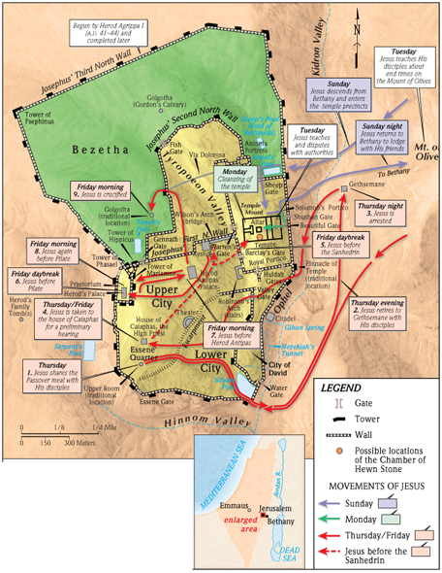

The Passion Week in Jerusalem

